Determine outside AQI_{PM}:
- AQI forecast from EPA, AirNow, CARB, or other online resources
- Measure PM2.5 with compliant direct-reading instrument
If outside AQI_{PM} >= 151:
- Communicate wildfire hazard risk to employees
- Control exposure:
  - Apply engineering controls (filtration)
  - Reduce exposure by relocating work, shorten shifts, etc.
  - N95 voluntary; Must supply N95s, fit test not required
If outside AQI_{PM} >= 500:
  - N95 required; fit test required
Worksite Exemptions:
- Mechanically ventilated building with windows/doors/bays closed as possible
- Enclosed vehicle with filtered cabin air
- Can demonstrate worksite AQI_{PM} < 151 with compliant direct-reading instrument
- Employees have less than 1 hour of exposure
- Wildland firefighters
Compliant Direct-Reading Instrument
- Does not underestimate wildfire smoke or manufacturer has specified the potential error
- Measures concentration of particles between 0.3 and 2.5 um
- Calibrated, maintained, and used per manufacturer instructions
- Reports AQI_{PM} values
- User is properly trained on the instrument

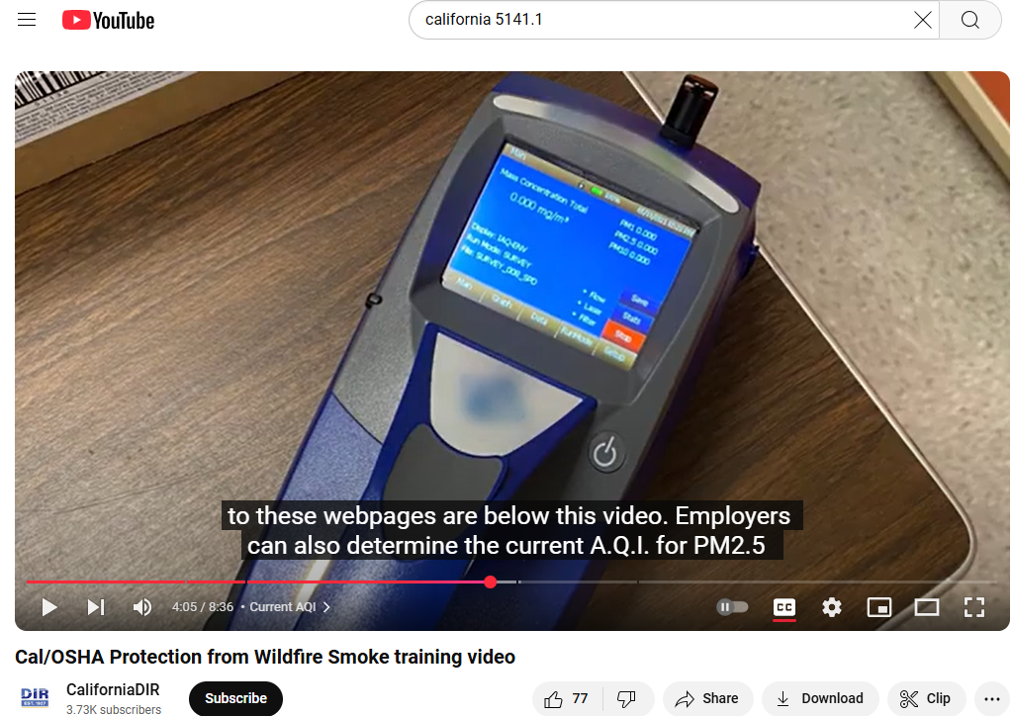1https://www.youtube.com/watch?v=cJYGNDNZOkc

